Question 1
a.
> # Load the library
> library(MASS)
> # Load the data into your environment
> data(crabs)
> ?crabs
The crabs data frame has 200 rows and 8 columns, describing 5 morphological measurements on 50 crabs each of two colour forms and both sexes, of the species Leptograpsus variegatus collected at Fremantle, W. Australia.

b.
> str(crabs)
'data.frame': 200 obs. of 8 variables:
$ sp : Factor w/ 2 levels "B","O": 1 1 1 1 1 1 1 1 1 1 ...
$ sex : Factor w/ 2 levels "F","M": 2 2 2 2 2 2 2 2 2 2 ...
$ index: int 1 2 3 4 5 6 7 8 9 10 ...
$ FL : num 8.1 8.8 9.2 9.6 9.8 10.8 11.1 11.6 11.8 11.8 ...
$ RW : num 6.7 7.7 7.8 7.9 8 9 9.9 9.1 9.6 10.5 ...
$ CL : num 16.1 18.1 19 20.1 20.3 23 23.8 24.5 24.2 25.2 ...
$ CW : num 19 20.8 22.4 23.1 23 26.5 27.1 28.4 27.8 29.3 ...
$ BD : num 7 7.4 7.7 8.2 8.2 9.8 9.8 10.4 9.7 10.3 ...
The data set has 200 individual crabs (rows) and 8 specific pieces of information about each (columns).

c.
> # Create a frequency table for species (sp) and sex
> crab_counts <- table(crabs$sp, crabs$sex)
>
> # Display the table
> addmargins(crab_counts)

F M Sum
B 50 50 100
O 50 50 100
Sum 100 100 200
The table shows an identical distribution of 50 crabs for every possible combination: Blue Females, Blue Males, Orange Females, and Orange Males. The addmargins() function further clarifies that each species has 100 representatives and each sex has 100 representatives, ensuring that any subsequent statistical comparisons between these groups such as testing if Orange crabs are significantly larger than Blue crabs will not be biased by unequal sample sizes.

d.
> # 1. Create a frequency table for plotting
> counts <- table(crabs$sex, crabs$sp)
>
> # --- Option A: Grouped Bar Chart ---
> barplot(counts,
+ beside = TRUE,
+ col = c("pink", "lightblue"),
+ main = "Crab Species and Sex Composition",
+ xlab = "Species (B=Blue, O=Orange)",
+ ylab = "Number of Crabs",
+ legend = c("Female", "Male"),
+ args.legend = list(x = "topright"))

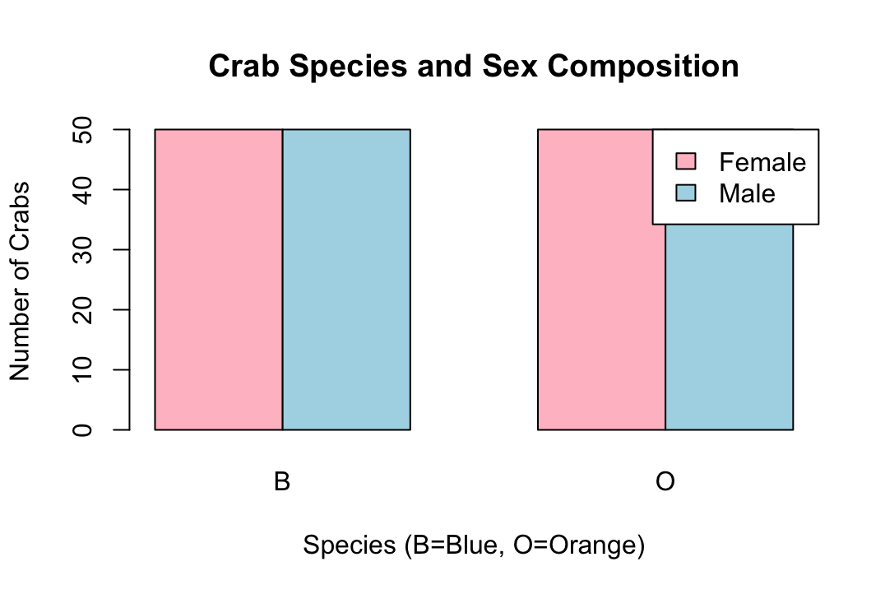

e.
The y-axis represents the number of crabs, while the x-axis groups them by species ("B" for Blue, "O" for Orange) and within those groups by sex ("Female" in pink, "Male" in light blue). Because all four bars reach the exact same height of 50, it visually confirms that each subgroup Blue Females, Blue Males, Orange Females, and Orange Males consists of an identical sample size of 50 individuals.
The bar chart effectively visualizes the balanced experimental design of the crabs dataset.

Question 2
a.
> boxplot(BD ~ sp * sex, data = crabs,
+ main = "Body Depth by Species and Sex",
+ xlab = "Group (Species.Sex)",
+ ylab = "Body Depth (mm)",
+ col = c("pink", "lightblue", "pink", "lightblue"),
+ names = c("B.F", "O.F", "B.M", "O.M"))

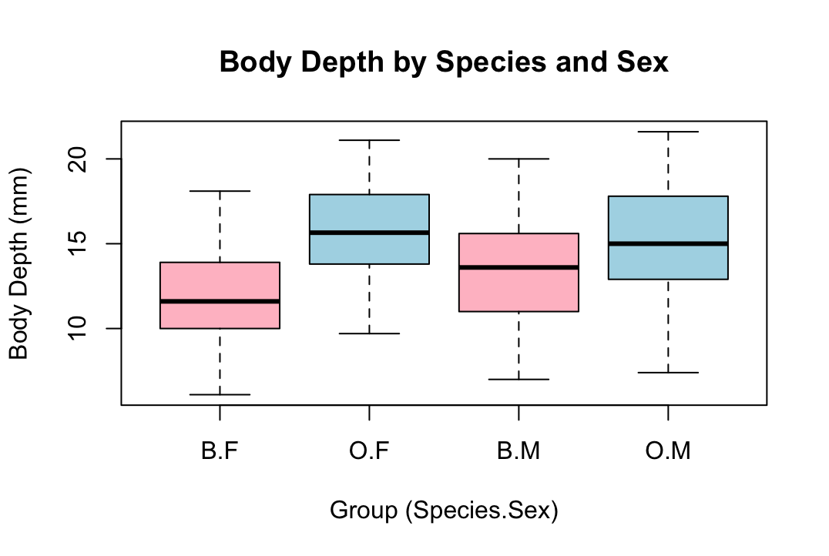

b.
There are no visible outliers plotted as individual points beyond the whiskers for any of the groups, indicating that the data for BD is relatively compact within its range. Comparing central tendencies, the median body depth is clearly highest for the Orange Females ("O.F"), followed closely by Orange Males ("O.M"), while Blue Females ("B.F") exhibit the lowest median body depth, suggesting a general trend where Orange species are physically deeper than Blue species, and females are typically deeper than males within the same species. In terms of variability, the Orange Females ("O.F") show the largest interquartile range (IQR), indicating higher spread and diversity in body depth measurements within that group compared to the other three groups, which appear to have similar, narrower variability.

Question 3
> # Set up a plotting area with 2 rows and 1 column to compare them easily
> par(mfrow = c(2, 1))
>
> # Histogram for Blue species ("B")
> hist(crabs$CL[crabs$sp == "B"],
+ main = "Carapace Length: Blue Species",
+ xlab = "Carapace Length (mm)",
+ col = "lightblue",
+ xlim = c(10, 50)) # Setting x-limits makes comparing easier
>
> # Histogram for Orange species ("O")
> hist(crabs$CL[crabs$sp == "O"],
+ main = "Carapace Length: Orange Species",
+ xlab = "Carapace Length (mm)",
+ col = "orange",
+ xlim = c(10, 50))
>
> # Reset plotting parameters
> par(mfrow = c(1, 1))

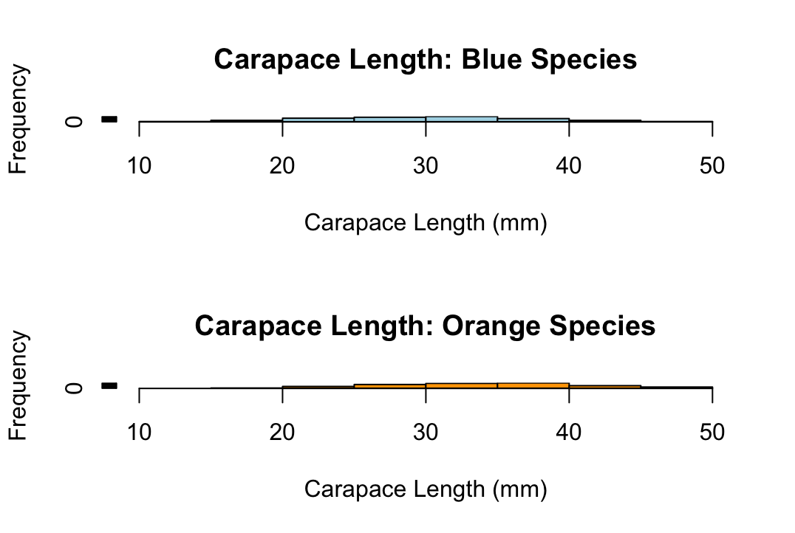

The histograms comparing Carapace Length (CL) for the two species both exhibit a generally symmetric shape with no significant skewness, as the data is relatively evenly distributed around the central peaks. The histogram for the Blue species appears unimodal, with a single, clear central peak, whereas the histogram for the Orange species suggests a bimodal or slightly broader distribution, indicating two potential clusters of size frequency within that population.

Question 4
# Formula: c(FL, RW, CL, CW, BD) ~ sp + sex
> # Means for measurements ~ grouped by species and sex
> crab_means <- aggregate(cbind(FL, RW, CL, CW, BD) ~ sp + sex,
+ data = crabs,
+ FUN = mean)
>
> # Display the resulting table
> print(crab_means)
sp sex FL RW CL CW BD
1 B F 13.270 12.138 28.102 32.624 11.816
2 O F 17.594 14.836 34.618 39.036 15.632
3 B M 14.842 11.718 32.014 36.810 13.350
4 O M 16.626 12.262 33.688 37.188 15.324

b.
# 1. Calculate the means (as done previously)
> crab_means <- aggregate(cbind(FL, RW, CL, CW, BD) ~ sp + sex,
+ data = crabs,
+ FUN = mean)
>
> # 2. Reformat the data for plotting (matrix format required by barplot)
> # We need the measurements as rows and groups as columns
> means_matrix <- t(as.matrix(crab_means[, 3:7]))
> colnames(means_matrix) <- paste(crab_means$sp, crab_means$sex, sep = ".")
>
> # 3. Create the grouped bar chart
> barplot(means_matrix,
+ beside = TRUE, # Grouped, not stacked
+ col = c("lightblue", "lightgreen", "lightyellow", "lightpink", "lavender"),
+ main = "Mean Morphological Measurements by Group",
+ xlab = "Group (Species.Sex)",
+ ylab = "Mean Measurement (mm)",
+ legend.text = c("FL", "RW", "CL", "CW", "BD"),
+ args.legend = list(x = "topleft", bty = "n"))

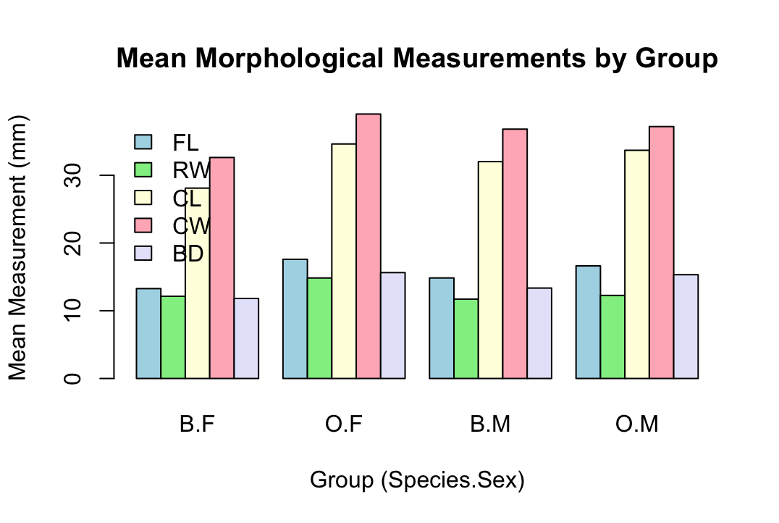

c.
The bar chart show mean morphological measurements, Carapace Width (CW) displays the greatest difference between the Blue ("B.F", "B.M") and Orange ("O.F", "O.M") species, as indicated by the distinct gap between the corresponding pink bars for the two species groups. Conversely, Frontal Lobe size (FL) shows the least variation between sexes, as the blue bars representing females and males are very similar in height within each species group.

Question 5
a.
> # Create a scatterplot matrix
> # We only select columns 4 through 8 (the numerical measurements)
> pairs(crabs[, 4:8],
+ main = "Scatterplot Matrix of Crab Measurements",
+ pch = 21, # Filled circle points
+ bg = c("blue", "orange")[unclass(crabs$sp)], # Color by species
+ col = "black") # Border color for points
>
> # Add a legend for species
> legend("topright",
+ legend = levels(crabs$sp),
+ col = c("black", "black"),
+ pt.bg = c("blue", "orange"),
+ pch = 21)
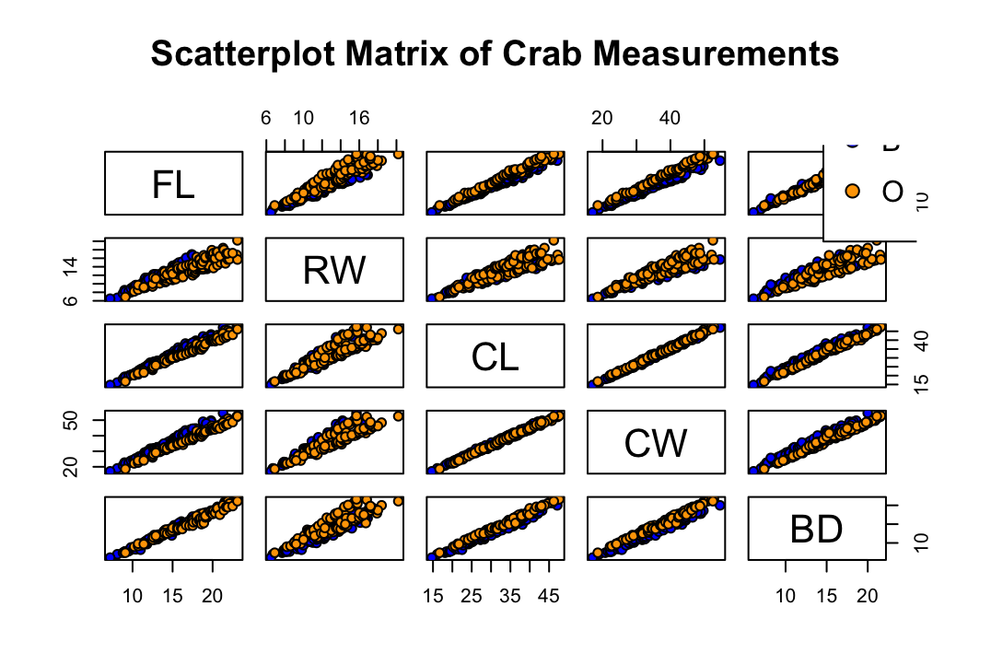

b.
The relationships among the five variables (FL, RW, CL, CW, BD) are characterized by strong, positive linear correlations. As any one measurement increases, the others tend to increase proportionally, which is visually demonstrated by the tight, upward-sloping diagonal lines of data points in the scatterplots. Furthermore, the scatterplots allow for species differentiation, showing that the Orange species ("O") generally plots higher and further to the right than the Blue species ("B"), indicating that Orange crabs are physically larger across most dimensions, particularly in measurements like Carapace Width (CW) and Length (CL).

Question 6
Introduction
The crabs dataset, contained within the MASS package in R, provides a detailed morphological analysis of 200 individual crabs. The data includes five physical measurements (Frontal lobe size, Rear width, Carapace length, Carapace width, and Body depth) taken from 50 crabs of each color form (Blue and Orange) and both sexes. This study aims to analyze the structure of this dataset, assess morphological differences between species and sexes, and examine the relationships between these physical measurements.
Data Structure and Experimental Design
An inspection of the data structure reveals a perfectly balanced experimental design, consisting of 200 observations across 8 variables. The categorical variables sp (Species) and sex are stored as factors with two levels each: Blue ("B") and Orange ("O") for species, and Female ("F") and Male ("M") for sex.
A frequency analysis confirms the balanced nature of the study, with exactly 50 individuals represented in each of the four possible combinations of species and sex (Blue Females, Blue Males, Orange Females, and Orange Males). This design is highlighted in the contingency table and corresponding bar chart below, showing an equal distribution across all groups.

Morphological Comparison by Group
Analysis of the Body Depth (BD) variable reveals distinct morphological differences between the groups. As shown in the boxplots above, there are no visible outliers in body depth for any of the groups. Comparing central tendencies, Orange Females ("O.F") exhibit the highest median body depth, followed by Orange Males ("O.M"). Conversely, Blue Females ("B.F") display the lowest median body depth. These findings suggest a general trend where the Orange species is physically deeper than the Blue species, and females are typically deeper than males within their respective species. In terms of variability, the Orange Female group shows the largest interquartile range (IQR), indicating a higher spread and diversity in body depth measurements compared to the other groups.
Carapace Length Distribution
Examining the Carapace Length (CL) via histograms allows for a comparison of the distribution shapes between the two species. Both species exhibit generally symmetric distributions with no significant skewness. However, the Blue species histogram is unimodal, featuring a single, clear central peak. In contrast, the Orange species histogram suggests a bimodal or broader distribution, indicating two potential clusters of size frequency within that population.
Mean Measurements Analysis
Calculating the mean for each morphological measurement provides a quantitative overview of the differences highlighted by the visual plots.
The grouped bar chart illustrates that Carapace Width (CW) displays the greatest difference between the Blue and Orange species, with the Orange species possessing noticeably wider carapaces on average. Conversely, Frontal Lobe size (FL) shows the least variation between sexes, as the average measurements for females and males are very similar within each species group.
Relationships Among Measurements
Finally, a scatterplot matrix was used to examine the relationships between all numerical variables.
The relationships among the five variables (FL, RW, CL, CW, BD) are characterized by strong, positive linear correlations. As any one measurement increases, the others tend to increase proportionally, demonstrated by the tight, upward-sloping diagonal lines of data points in the scatterplots. Furthermore, these plots facilitate species differentiation, showing that the Orange species generally plots higher and further to the right than the Blue species, indicating that Orange crabs are physically larger across most dimensions, particularly in Carapace Width (CW) and Length (CL)

